Optional- Part5: Create an Auto-Scaling group

* 1. Delete the three instances. Do NOT delete the load balancer.
  2. Select Auto Scaling Groups under Auto Scaling on your EC2 Dashboard.
  3. Click My AMIs on the left and select the Ubuntu AMI you created earlier.
  4. Select a t2.micro.
  5. Enter a name for the Launch Configuration, such as “Ubuntu Instances.”
  6. Select your SSH/HTTP security group.
  7. Add your Key Pair and create the launch configuration.
  8. On the Create Auto Scaling Group screen (see screen shot, below):
  9. Enter a Group Name, like “Lab4-ASG.”
  10. Set the Group size to 2 instances.
  11. In the Subnet field, select all four subnets in your region.
  12. Under Advanced Details, check “Receive traffic from one or more load balancers.”
  13. In the Class Load Balancer field, select your ELB.
  14. Select the ELB button for the Health Check Type.

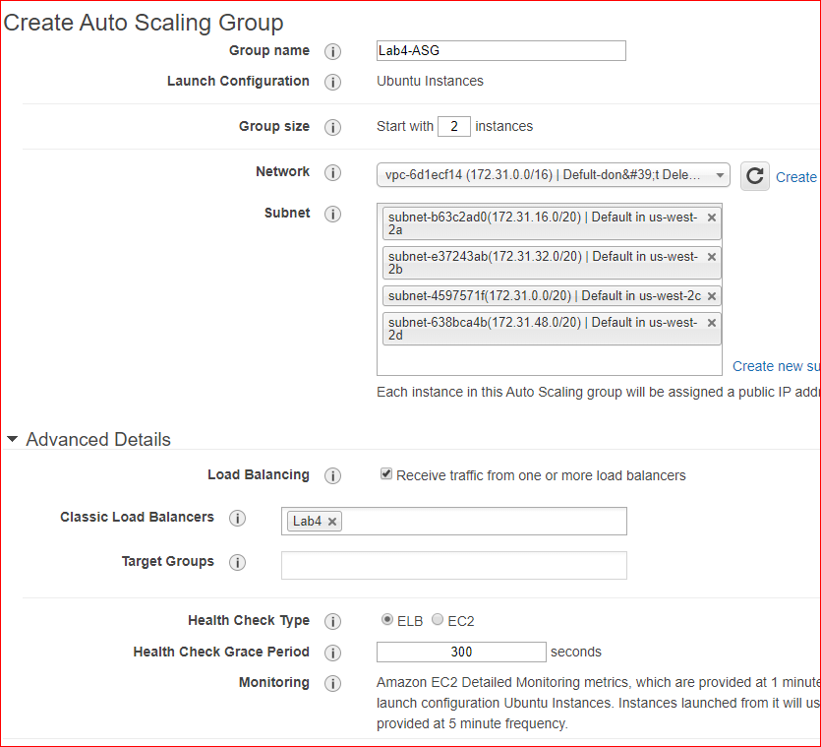

* 1. On the Create Scaling group page, click the “Use scaling policies to adjust the capacity of this group” button.
  2. Scale between 2 and 4 instances.
  3. Click on “Create a simple scaling policy” blue text under both the Increase Group Size area and Decrease Group Size area.
  4. For Increase Group Size click “Add new alarm.”
     1. Uncheck “Send a notification to.”
     2. Set Average CPU utilization >= 60 percent for a period of **1** minute.
     3. Create a readable name for the alarm.
     4. Set “For at least” “1” of “1 minute.”

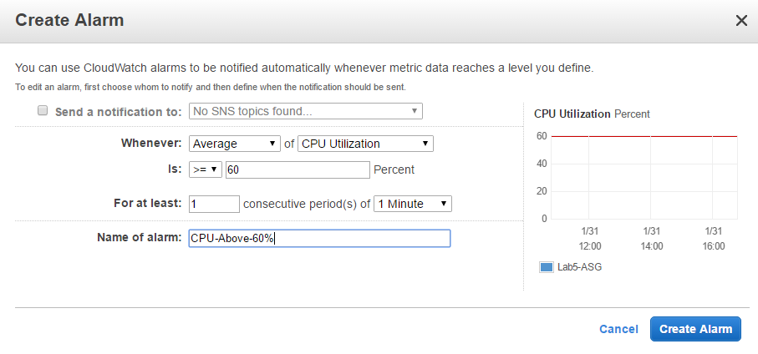

* + 1. Back on the Increase Group Size screen, set “Take the action” to Add 1 instance.

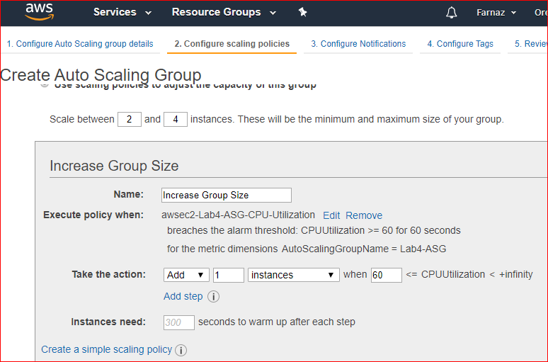

* 1. For Decrease Group Size “Add an alarm.”
     1. Uncheck “Send a notification to.”
     2. Sent Average CPU utilization <= 20 percent for a period of **1** minute.
     3. Create a readable name for the alarm.
     4. Set “For at least” “1” of “1 minute.”

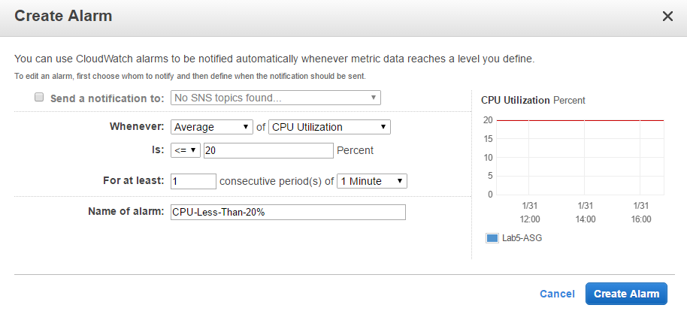

1. Back on the Decrease Group Size screen, set “Take the action” to Remove 1 instance.
   1. Don’t add any notifications.
   2. Create Key value of “Name” and a Value of “Lab4-Ubuntu-ASG”
   3. Review and launch the auto-scaling group (ASG).
   4. Go to your EC2 Dashboard. You should see two new instances being created.
   5. After each instance has been created, enter the Public IP address for each instance into your browser.
   6. Go to your ELB (load balancer).
   7. Your instances will eventually be automatically added to the ELB.
   8. Verify they have been added to the ELB.
   9. Copy the DNS Name of your ELB into your browser to verify that you are switching between the two instances.
   10. Stress test the CPU running on your web server instance.
   11. SSH into one of the instances.
   12. Run “sudo su.”
   13. Then type “stress –cpu 100” [two hyphens before cpu; runs 100 processes]
   14. Go back to your EC2 console. On the instance you are running the stress test, monitor the CPU utilization. Have patience! This should spike after about 5 - 10 minutes.
   15. You should see a new instance being automatically created. For me, it took about 10 minutes before the new instance was launched.

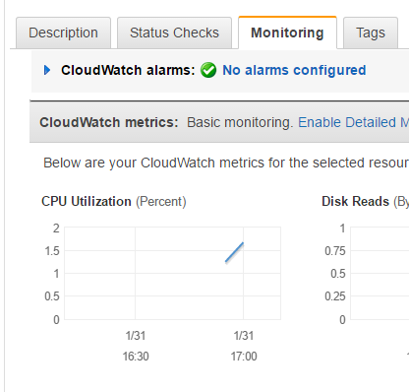

* 1. After the third instance is created, close the SSH connection. This will stop the stress test. Do you still have three instances running?